## HCL ADAPTER

## Prerequisite for project with version

* Java 1.8
* STS/Eclipse
* Orient Db Installation (latest stable version)
* Configured ADDI application
* Apache Maven 3.6.0

(Note: All the dependency included in pom.xml, no need to add externally)

## Steps for project execution

1. **Download ADDI**

* Click on the below link to download the HCLAdapter project

[https://hclo365.sharepoint.com/sites/ADDIProject/Shared%20Documents/General/HCLAdapter-0.0.2-SNAPSHOT.zip](https://hclo365.sharepoint.com/sites/ADDIProject/Shared%20Documents/General/HCLAdapter-0.0.2-SNAPSHOT.zip%20)

* Path to download project from Microsoft teams: ADDIProject/files/ADDI/
* Download the project and create new folder inside local disk ‘C’ with name “ADDI-WS”
* Copy downloaded project in “ADDI-WS”

1. **Importing ADDI**

* To import ADDI application in STS environment follow the below steps
* Download the STS <https://spring.io/tools3/sts/all> with link for windows(download STS with latest version or 3.9.7 )
* Extract the downloaded STS and open it
* Click on ‘file and select ‘import’
* Then click on ‘Maven’ and select ‘Existing Maven Project’ (Refer Fig-0.0.1)
* Click on ‘Browse’ and go into the “ADDI-WS” directory and select the project (Refer Fig-0.0.2)
* After project selection clicks on ‘finish’

(Note: Internet is required because it will download the repositories)

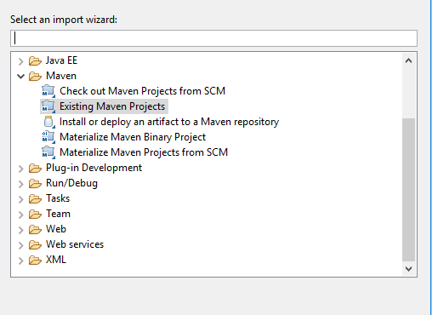

Fig-0.0.1

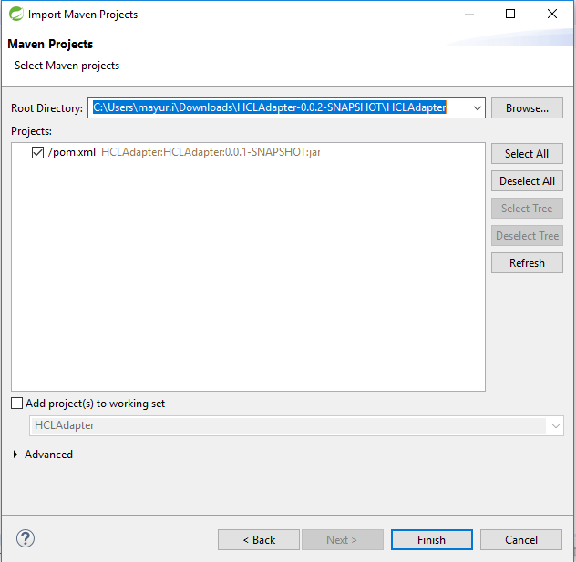

Fig-0.0.2

1. **OrientDB installation**

**For Windows**

* Download OrientDb latest version through the link [https://orientdb.org/download](https://apac01.safelinks.protection.outlook.com/?url=https%3A%2F%2Forientdb.org%2Fdownload&data=02%7C01%7Cpiyush.c%40hcl.com%7C0afe9f58bba74b3f501208d69e090585%7C189de737c93a4f5a8b686f4ca9941912%7C0%7C0%7C636870158913489770&sdata=ZImcSco4GvpegerSAk%2FMvS4%2BEixC%2BqmNMLjNHPonxvg%3D&reserved=0).
* Extract the downloaded OrientDb and switch to bin directory.
* Execute the “**server.bat**” file in command prompt.
* <http://localhost:2480/studio/index.html#/> refer this link to open home page.
* Create new DB with name “**ADDIdb**” and set username “**addi**” password “**Addidb@123**”

**For Linux**

* Download OrientDb latest version through the link [https://orientdb.org/download](https://apac01.safelinks.protection.outlook.com/?url=https%3A%2F%2Forientdb.org%2Fdownload&data=02%7C01%7Cpiyush.c%40hcl.com%7C0afe9f58bba74b3f501208d69e090585%7C189de737c93a4f5a8b686f4ca9941912%7C0%7C0%7C636870158913489770&sdata=ZImcSco4GvpegerSAk%2FMvS4%2BEixC%2BqmNMLjNHPonxvg%3D&reserved=0).
* Extract the downloaded OrientDb and switch to bin directory.
* Execute the “**server.ch**” file in command prompt.
* Create new DB with name “**ADDIdb**” and set username “**addi**” password “**Addidb@123**”

**Note: If you have already configured ADDI application and Orient Db you can skip this step.**

1. **Execution of the ADDI application**

Please refer ADDI Developer Installation guide and ADDI Installation guide to configure and execute the ADDI application.

1. **Execution of HCLAdapter**

* Create two folders with any suitable name.
* Consider ‘InputJson’ and ‘OutputJson’ respectively.
* Basically HCLAdapter requires three parameters, first is the json file location path where Input file is kept.
* Input file is nothing but all requests in json format will be kept altogether.
* Second parameter is ‘InputJson’ folder path where all InputJson files will be created as per Inputs.
* Third parameter is for ‘OutputJson’ folder path where all requested output response coming from ADDI application will be saved.

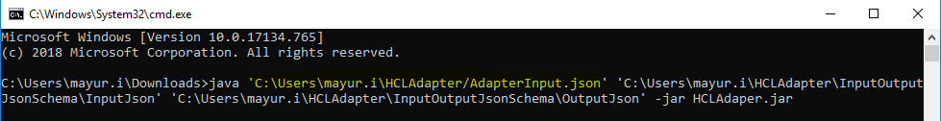

* As you can see ‘**C:\Users\mayur.i\HCLAdapter/AdapterInput.json**’ is the Input json file location where all Inputs are kept. ‘**C:\Users\mayur.i\HCLAdapter\InputOutputJsonSchema\InputJson**' and **‘C:\Users\mayur.i\HCLAdapter\InputOutputJsonSchema\OutputJson**’ are **Input and output folder** path respectively.

Note: HCLAdapter.jar is the jar which you can download through below link <https://hclo365.sharepoint.com/sites/ADDIProject/Shared%20Documents/General/HCLAdapter-0.0.1-SNAPSHOT.jar>